Special Educational Needs:
Information Report
2023 - 2024

How we support children with Special Educational Needs or Disabilities

“By recognising Jesus Christ in ourselves and others, our school strives to be a living Christian Community which values and nurtures each individual through a sound education and encourages responsible attitudes towards our changing world.
___________________________________________________________________________
St. Louis Catholic Academy is a primary school and nursery. We admit children from the age of three years to eleven years. At the end of Year 6 our pupils go on to a range of secondary schools, including St. Benedict’s Catholic School in Bury St. Edmunds, Newmarket Academy, Bottisham Village College and Soham Village College.
CEO (Trust) Mr Flavio Vittese
Primary Improvement Lead Mrs Clare Clark
Head Teacher Mrs Sue Blakeley
Governor responsible for Safeguarding Mrs Karen Varma
Governor responsible for SEND Mrs Jenny Balmer
SENCo Mrs Kerri Conway
SENCO email: senco@stlouisacademy.co.uk
NASENCO Qualification – August 2023
Senior Mental Health Training – May 2023
Contents:
Suffolk Local Offer Information
Current SEND Data Information
How do we ensure that children who need extra support to ensure progress are identified early?
What is SEN Support?
How are staff trained in relation to supporting children with special educational needs?
What should a parent do if they think their child may have special educational needs?
How do we support children who have special educational needs?
What is a Learning Plan?
How does the school adapt the curriculum and learning environment for pupils with special educational needs?
Which other people provide services to children with SEN?
How are the school’s resources allocated and matched to children’s special educational needs?
How do you measure my child’s progress?
How will my child be included in all activities in school, including those outside the classroom including day and residential trips?
How will we support new children with special needs when they join our school?
How will we support your child when they leave our school or move into another class?
How are school Governors involved and what are their responsibilities?
How is St. Louis Catholic Academy accessible to children with SEN?
Links to other school policies

Suffolk Local Offer Information
Welcome to our SEN Information Report which is part of St Louis Catholic Primary Academy’s contribution to the Suffolk Local Offer for learners with Special Educational Needs (SEN) and disabilities, which can be found here: Home - Suffolk SEND Local Offer (suffolklocaloffer.org.uk)
The Suffolk Local Offer provides information and advice for families and young people with SEND in Suffolk.
West: 01284 741234 / SENDWS@suffolk.gov.uk
EHCNA Request Team 01473 263688 EHCNArequest@suffolk.gov.uk
Local Offer Line 0345 606 1490 localoffer@suffolk.gov.uk

Current SEND data Information
St Louis 2023 - 2024 SEN Report (accurate as of June 2024)
Total Number of Pupils (Jan 2023) R-Yr6 | 299
Pupils on SEN Record | 29 | 10.3%
Pupils with EHCP | 1 | 0.3%
Pupils with SEN Support | 28 | 10%

The majority of children’s primary SEN at St. Louis is Cognition and Learning at 52% with Communication and Interaction at 10%, Social, Emotional or Mental Health 24% and Sensory/Physical 14%. We do have children whose areas of need overlap and many children have more than one area of need – the pie-chart on the next page is a representation of each child’s primary area of need as identified by class teachers or other professionals. Therefore, it is important to note that although a child’s primary need may be Communication and Interaction or Cognition and Learning, they may still have support for Social, Emotional and Mental Health Needs. The high level of Cognition and Learning need is reflected in the provisions we offer within school, though we realise the value of all types of therapies and interventions and we adapt to the needs of the learners in our care.

Below are the four broad areas of SEN and how they may present.
We adapt our teaching and learning for children with SEN to offer personalised education. Every child at St Louis Catholic Primary Academy benefits from high quality teaching. Children on the SEN record may also access additional interventions or teaching and learning strategies to enable them to make the best possible progress.
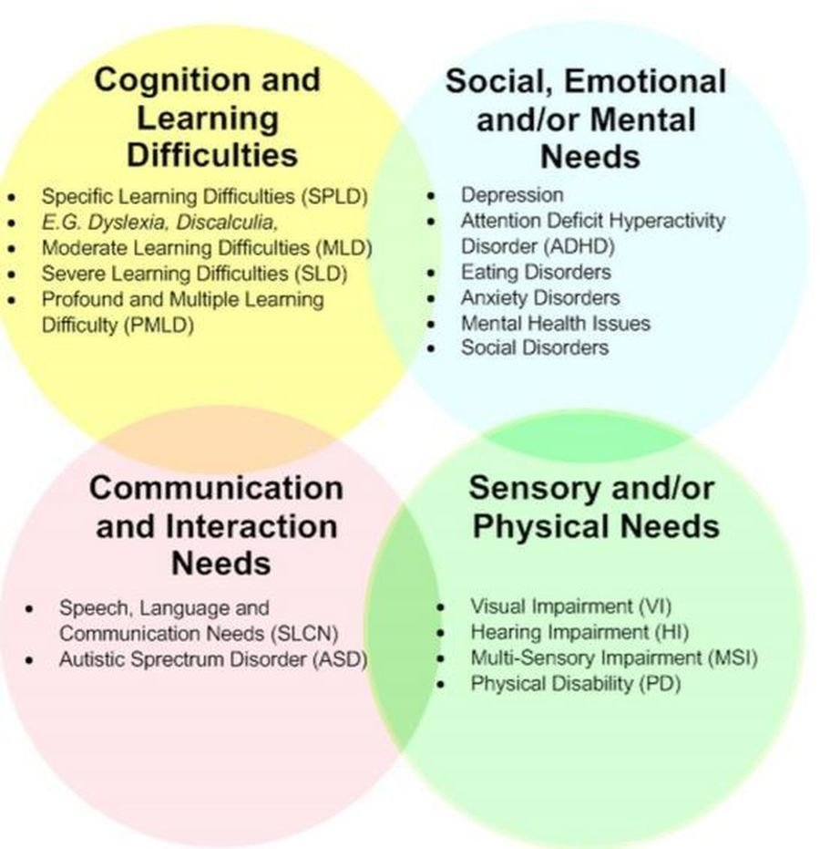
How do we ensure that children who need extra support to ensure progress are identified early?
A child has a Special Educational Need if he or she has a learning difficulty or disability that means he or she has a significantly greater difficulty in learning than the majority of others of the same age, or has a disability which prevents or hinders him or her from making use of facilities of a kind generally provided for others of the same age in mainstream schools. When we identified this need, the child will be recorded on the school SEN Record as ‘SEN Support.’

What is SEN Support?
SEN Support is the system we use in school to assess whether a child has special educational needs and then we can provide the right, targeted support.
Children are identified as having special educational needs in a variety of ways including the following:
- Child performing significantly below age expected levels (normally 12 months+)
- Concerns raised by parent
- Concerns raised by class teacher
- Consultations between class teachers and head teacher where progress data is discussed
- Liaison with external agencies e.g. Speech and Language Therapy Service
- Health diagnosis through a paediatrician
- Liaison with previous school or setting, if applicable
If a concern is raised regarding a child, a range of evidence will be collected through assessment and monitoring, including the following:
- Early Learning Goals – Early Years Foundation Stage
- Year 1 Phonics Screening test
- National Curriculum Tests - Year 2 and Year 6
- A range of standardised tests
- Classroom observation

How are staff trained in relation to supporting children with special educational needs?
Mrs Kerri Conway is St Louis school SENCO and she has undertaken the National Award for SENCO’s during her first year in post. She has also completed Senior mental health lead training with Anna Freud and is a Designated Safeguarding Officer within the school. She has enabled training of staff in school through staff meetings with both teachers and teaching assistants, as well as organising training through the local authority. Staff have been trained on the use of Provision Mapping software as well as the creation of Learning Plans. There has been whole school training on the Zones of Regulation. Staff are regularly briefed on expectations for adults on the support of children with SEND in school by the SENCO and relevant research from bodies such as EEF is shared. Teachers regularly review the school SEN Record, led by Mrs Conway and children’s needs are discussed in detail.

What should a parent do if they think their child may have special educational needs?
Talk to us. In the first instance contact your child’s class teacher. The teacher may make the decision to involve the Special Educational Needs Co-ordinator (SENCO) for further advice or information or you may contact the SENCO directly yourself by making an appointment through the school Reception office or by email at senco@stlouisacademy.co.uk

How do we support children who have special educational needs?
We value high quality teaching for all learners and actively monitor teaching and learning in the school. Our teachers deliver quality learning opportunities which are adapted to the needs of all children through careful planning and scaffolding. We aim to create a learning environment which is flexible enough to meet the needs of all members of our school community. Staff continually assess and monitor the progress of all of our pupils to enable us to identify any gaps in their learning and intervene early. The majority of our SEND support is carried out in the classroom to promote inclusion, ensure every learner has access to a broad and balanced curriculum as well as Quality First Teaching.
We believe that, where possible, Quality First Teaching should cater for all children’s needs. Reasonable adjustments should be made to ensure all pupils have access to learning and overcome any barriers to progress. Every teacher is required to adapt the curriculum to ensure access to learning for all children in their class. The teacher standards (2012) detail this expectation. Our teachers use various strategies to adapt access to the curriculum including visual timetables, concrete materials, coloured overlays, tablets, laptops, positive behaviour reward systems, writing frames and individual behaviour plans. Teachers carefully consider how they give instructions and the way in which they communicate with different children. They ensure that pupils are clear on what is expected in lessons and understanding is checked regularly. We are also equipped with disabled toilets and a lift for children with physical difficulties or who have intimate care requirements.
The table on the next page details the structured support we put in place and the order in which this will occur.

Universal offer- has an identified additional need but is making good progress | Needs met through QFT  Advice sought from SENCO where needed  Progress monitored through termly Pupil Progress meetings  Monitoring from SENCO through learning walks/book scrutinies/pupil voice  Parents evenings  Access to training as appropriate  Whole school policies and procedures in place
Universal targeted – needs are not being met through QFT | Teacher seeks advice from SENCO  Appropriate interventions put in place using resources from within school  Progress of interventions monitored closely through provision map  Use of additional assessments where needed
Targeted – child may need resources or support from one or more outside agencies | Child added to SEN Record and an individual learning plan is created between teachers and parents  SENCO seeks advice from external agencies  Additional training may be needed to support the child in school  SENCO may make referral to specialist education services  Consider EHA assessment
Targeted Specialist – child needs a range of outside specialist support | Child has multi agency involvement  Child will be working towards, or will already have, an EHCP  SENCO to seek advice where necessary from outside specialists  Training for adults involved in the care of the child  Specialist assessments are used to recognise steps in learning  Monitoring of the support being provided  Regular communication with parents

Where a child has an EHCP or Learning Plan in place, we gather information from parents and the child to inform our target setting and review any plans. Plans are shared with parents termly, who offer feedback and we have an open-door policy, whereby parents are welcome to come and discuss things in further detail if they wish.
Parents are also surveyed on a yearly basis to gather their views and these responses are used to inform future planning and how we can better support both pupils and parents. This year for example, one parent raised that they would like face to face meeting to be reinstated for the discussion of learning plans and therefore this is something we will discuss as a Senior Leadership Team and look to review going forward. Pupils are also surveyed on a yearly basis as getting pupil views and opinions is of great importance to us. This is completed by Mrs Conway and results are shared in school. Pupils with Learning Plans also meet with their class teacher termly to review their One Page Profile and discuss their own targets and set new goals. Children with SEND are also encouraged to participate in all aspects of school life including becoming a School Councilor or Play Leader.

What is a Learning Plan?
Pupils with SEND at St Louis have a personalised Learning Plan which identifies their barriers to learning and how we intend to support them moving forward. This closely monitors progress and celebrates achievement. This support your child may receive is described on our provision map and is also detailed on their Learning Plan. The ‘Assess, Plan, Do, Review’ cycle is used at least termly in order to set appropriate targets for progress and put support in place. Whilst the majority of children’s needs are catered for within the classroom, we have a number of programmes to support pupils further if necessary.
These programmes include:
- Small group Maths or English based key skills lesson
- 1st Class @Number
- Additional Little Wandle Phonics (Catch up or Keep up sessions)
- Social, Emotional and Behavioural Skills group
- Literacy gold
- Dynamo Maths
- Speech and Language: NELI and Wellcomm
- Sensory Circuits
- Lego therapy
- Lunchtime Calm Club
Assess: Discussion with staff to build profile of need. Gather and analyse assessment information.
Review: Check the quality, effectiveness and impact of the provision, involving the child and their parents/carers.

Child

Plan: Work together to create 7C’s Learning Journey, utilising whole school approaches, quality first teaching and adaptation strategies.
Do: Put in place the agreed adjustments, support and interventions.

How does the school adapt the curriculum and learning environment for pupils with special educational needs?
Dependent on the need of the child, we use a wide variety of adaptations of both the curriculum and learning environments for pupils with SEND. These include, but are not limited to:
- Making written information more accessible through the use of off-white backgrounds on all our teaching slides, use of coloured paper, overlays, reading rulers.
- How the classroom is organised and where children sit in the classroom
- How we use our adults best for 1:1 or small group support where needed
- Exam access arrangements
- Using technology to make learning more accessible e.g. purple mash, literacy gold, typing opportunities, children can type rather than write, tablets, hearing devices.
- Adaptations of lesson resources
- Adapting the physical environment to ensure safety and ease of use.
- Flexible groupings
- Visual and multi-sensory resources
- Specialist equipment e.g. pencil grips, wobble cushions
- Individual timetables

Which other people provide services to children with SEN?
St Louis Catholic Academy has close working relationships with a number of external agencies, whose specialist knowledge and advice enhance children’s learning and wellbeing. These agencies include:
- Community Consultant Paediatricians
- Speech and Language Therapy
- Occupational Therapy
- Physiotherapy
- Educational Psychology
- Specialist Education Service
- Advisory Teacher - Communication and Interaction
- Advisory Teacher – Cognition and Learning
- Advisory Teacher – Social, Emotional and Mental Health
- Advisory Teacher- Sensory and Physical Schools’ Nursing Service
- Family Support Practitioners

How are the school’s resources allocated and matched to children’s special educational needs?
We ensure that all children with special educational needs are provided for to the best of the school’s ability with the funds available. The budget is allocated on a needs basis to ensure that each child receives the support they require to enable them to make progress. The head teacher is responsible for allocating funding for supporting children and she consults with the business manager, SENCO and class teachers so that the best use possible is made of the funds available. The school is committed to offering appropriate support to all children and if a child needs additional support we strive to provide this. The majority of our High Needs Funding is spent on staffing; however, we use some of it to fund extra resources to support children, including specialist equipment, books or learning programmes. The school keeps a register of all children who require significant additional support. If a child makes good progress and meets the targets that have been set for them, they may be removed from the register and any higher needs finding previously sought for them, will be withdrawn. Monitoring of progress takes place for all children and whether a child has SEND or not, this monitoring will occur on an ongoing basis to ensure continued progress.

How do you measure my child’s progress?
As a school we measure children’s progress in learning against national age-related expectations (ARE). The class teacher continually assesses each child and notes areas where they are improving and where further support is needed through informal assessments such as questioning, low stakes testing and marking. On a termly basis we assess more formally in reading, writing and maths using Pixl tests. Children who are unable to access these are assessed by other means such as the Early Years Framework or the Pre-Key Stage Standards.
We track children’s progress from their admission through to Year 6, using the electronic systems, Evidence Me (EYFS), PiXL (Year 1 to 6) and Insight Tracker. When a child’s Learning Plan is reviewed at the end of each term, comments are made against each target to show what progress has been made. If the child has not met the target, the reasons for this will be discussed, then the target may be adapted into smaller steps or a different approach may be tried to ensure the child does make progress. Where a child is involved with an intervention programme, the impact of this will be measured by a post-intervention assessment and inform their next Learning Plan.

How will my child be included in all activities in school, including those outside the classroom including day and residential trips?
We aim for all children to be included in all aspects of school life. We achieve this through a range of support strategies including peer support, adult support and guidance as well as strategies for developing independence. We access therapies such as physiotherapy, speech and language therapy and occupational therapy. We purchase a range of specialist equipment where necessary or when recommended by external agencies. We carefully consider our physical environment and can offer quiet areas, ramps, changing facilities and take the needs of each child into account and adapt where we can. We also aim for all children to be included on school day trips and residential stays. We will provide the necessary adaptations, having consulted with parents, to ensure that this is successful. A risk assessment is carried out prior to any off-site activity to ensure everyone’s health and safety will not be compromised. Parents may be asked to attend if we feel this would be beneficial to the child, but is not necessary as other arrangements will be made if parents are unavailable.
How will we support new children with special needs when they join our school?
When children who have special needs join the school in Reception class the class teacher and SENCO will visit the child in their current nursey setting, or at home, in order to gain as much prior information about them as possible. We will arrange phone calls and email the parents and possibly also meet in person before the academic year begins. The child will be offered extra transitions and we are flexible with what we can do to meet the needs of each individual child. As this is on a case by case basis, any adaptations we could offer would be discussed with parents at the time.
Where a child joins us in a year other than reception, staff get to know them as information from the pervious school is passed over. The SENCO would speak with the previous school SENCO to get a fuller picture of the child and this information would be passed on to the class teacher. We have an open-door policy and are happy to meet with parents to further discuss any concerns and worries around the change and transition that they would have. Staff also work with the child to create their St Louis Learning Plan and One Page Profile to gain a better understanding of what their needs are and how to best support them.

How will we support your child when they leave our school or move into another class?
Before your child moves between classes, their current class teacher will meet with their new class teacher to share information and records. This enables the new class teacher to be best prepared and aware of any adaptations necessary for your child to make transition as smooth as possible. A transition visit may be arranged at the end of the summer holiday when the child can see their new classroom and meet their teacher.
Prior to transition between our school and secondary schools, the secondary school SENCO will meet with our SENCO and class teachers to discuss your child’s needs and may offer your child a series of transition sessions at their new school.
At St Louis we recognise that periods of change can be difficult for everyone and especially for our young people. Across the school, we use ‘Zones of Regulation’ as a mental and emotional health tool to support children in recognising their emotions and knowing how to regulate themselves. Teachers offer children regular brain or movement breaks and there are times of quiet reflection in the week and well as ad hoc opportunities for the practice of relaxation techniques, such as mindfulness and breathing exercises. Mrs Conway is our Senior Mental Health Lead and we have a range of other staff who have been trained as Mental Health First Aiders. We offer peer support and a lunch time calm club on a daily basis as well as Lego therapy and drawing and talking therapy for children who need extra nurturing, social or emotional support.

How are school Governors involved and what are their responsibilities?
The SENCO reports to the Governors to inform them about the progress of children with special educational needs or disabilities; this report does not refer to individual children and confidentiality is maintained at all times.
One of the Governors is responsible for special educational needs and meets regularly with the SENCO. She shares the responsibility to ensure all governors are informed about SEND matters with the SENCO.
Where a parent is not happy with the provision made available to their child in school, they should first ask for a meeting with Mrs Conway so the issue can hopefully be resolved. If this does not satisfy, they can have a further meeting with Mrs Blakeley, the Head Teacher.
If parents wish to make a formal complaint they should access the school complaints procedure at the end of this document.
If a parent or carer requires support in making a formal complaint, this is available via SENDIASS: https://suffolksendiass.co.uk/education/raising-concerns/#:~:text=make%20a%20complaint%20by%20writing,resolution%20or%20mediation%20(see%20dropdown)

How is St. Louis Catholic Academy accessible to children with SEN?
The new building in our school is fully accessible for children with physical needs, as there are ramps throughout and a lift to the first floor for easy access as well as accessible toilets. The organisation of classes within the old building would be reviewed to facilitate access for children with physical needs, as necessary. Several adaptations have been added to the ground floor, including a disabled toilet, a ramp, Disability Discrimination Act (DDA) approved hand rails and disabled parking space to the front of the building. There is currently ramp access to the Nursery class. All staff have access to SMART Boards and visual timetables are available. In addition, specialist equipment or resources can be adapted or ordered for individual children as and when they are deemed necessary.

Links to other school policies:
SEND Policy: https://www.stlouisacademy.co.uk/_site/data/files/new-folder/F59E7664339573D99039D8F582365BDD.pdf
Accessibility Plan: https://www.stlouisacademy.co.uk/_site/data/files/new-folder/7DDA73783E22B3D7AD7A8D56CF255BC8.pdf
Safeguarding Policy and Procedures: https://www.stlouisacademy.co.uk/_site/data/files/key-info/8ED9ED6AAE427F6E45A5650BE6911B12.pdf
Behaviour Policy: https://www.stlouisacademy.co.uk/_site/data/files/our%20school/policies/4E6D13E806B9E17CC2398344E6D038B4.pdf
Complaints Procedure: https://www.ourladyofwalsingham.co.uk/_site/data/files/docs/policies/trust/C335846760B9696F21B51ED459A46038.pdf
Medical Conditions: https://www.stlouisacademy.co.uk/_site/data/files/new-folder/71BA25DFEA7621C881951022E43EFE73.pdf
Admission Arrangements: https://www.stlouisacademy.co.uk/_site/data/files/our%20school/key%20information/CA3B5AA42AA9496C4F0E1ACDFB53CB30.pdf
Equality Information: https://www.ourladyofwalsingham.co.uk/_site/data/files/users/6/files/964BC17E90C23FBC028BC3E72F6EB469.pdf
All other policies and procedures can be found on the school website:
https://www.stlouisacademy.co.uk/page/?title=Policies+%26amp%3B+Financial+Information%26%238203%3B%26%238203%3B%26%238203%3B%26%238203%3B%26%238203%3B%26%238203%3B%26%238203%3B&pid=28
Updated June 2024. Will be next reviewed June 2025.

